**AECP - PRODUCT DOCUMENT**

**TABLE OF CONTENTS**

**1. Product Overview**

1.1. Product Description

1.2. Product Vision

**2. Target Audience**

2.1. Primary Audience

2.2. Secondary Audience

**3. Key Features**

**3.1. Managers attendance system & Automatic logout**

3.1.1. Description

3.1.2. Benefits

**3.2. Project management**

3.2.1. Description

3.2.2. Benefits

**3.3. Task management**

3.3.1. Description

3.3.2. Benefits

**3.4. Managers leave management**

3.4.1. Description

3.4.2. Benefits

**3.5. Timesheet**

3.5.1 Description

3.5.2. Benefits

**3.6. Notification system & Email system**

3.6.1. Description

3.6.2. Benefits

**3.7. Monthly report generator**

3.7.1. Description

3.7.2. Benefits

**3.8. Profile Management**

3.9.1. Description

3.9.2. Benefits

**3.9. Daily calendar management**

3.12.1. Description

3.12.2. Benefits

**4. User Interface (UI) Overview**

**5. System Architecture**

5.1. Technology Stack

5.2. Databases

5.3. Integrations

**6. Security Measures**

6.1. Data Encryption

6.2. Authentication

6.3. Authorization

**7. Roadmap**

7.1. Planned Updates

7.2. Enhancements

7.3. New Features

7.4. Estimated Release Dates

**8. Installation and Compatibility**

8.1. System Requirements

8.2. Platform Compatibility

8.3. Installation Instructions

**9. Getting Started**

9.1. Step-by-Step Instructions

**10. Contact Information**

10.1. General Inquiries

**11. Legal Information**

11.1. Disclaimers

11.2. Terms of Service

11.3. Privacy Policy

**12. Version History**

12.1. Version 1.0 (Release Date)

12.2. Key Changes

**13. Conclusion**

13.1. Summary of Key Points

13.2. Value and Benefits

**1. Product Overview**

**1.1. Product Description**

The Architecture, Engineering & Construction (AEC) Collection provides BIM and CAD software, including Revit, Civil 3D, and AutoCAD, as well as a cloud-based common data environment enabling designers, engineers, and contractors to efficiently deliver high-quality building and infrastructure projects. Powerful conceptual design tools help AEC professionals capture design intent, while model-based design solutions accelerate design processes and support integrated workflows for multi-discipline coordination. Analysis and optimization tools improve design quality and ensure constructability. Construction coordination and schedule simulation help reduce costs and minimize field coordination issues during construction. With the AEC Collection, teams can create with ease, explore what’s possible, and build with confidence.

**1.2. Product Vision**

To transform the AEC industry to international standards with value-added technology to enable engagement & collaboration between Architects, Engineers, Academic professionals, and beyond. Bringing high standards of employment and growth to this Industry.

**2. Target Audience**

**2.1. Primary Audience**

**1** **Project Owners/Clients:**

Content focusing on the benefits of the EPC model, such as single-point accountability, streamlined project management, and risk mitigation.

Case studies showcasing successful EPC projects, highlighting cost savings, timeline adherence, and quality outcomes.

**2** **Engineering Professionals:**

Technical articles or blog posts discussing innovative engineering solutions and best practices in EPC project design and execution.

Webinars or video tutorials on specialized engineering topics relevant to EPC projects, such as structural analysis, process optimization, or environmental compliance**.**

**3. Procurement and Supply Chain Managers:**

Content highlighting strategies for effective procurement and supplier management in EPC projects, including supplier evaluation criteria, negotiation tactics, and risk mitigation strategies.

Case studies demonstrating successful procurement practices that contributed to project cost savings, quality improvements, or schedule acceleration.

Guides or checklists for optimizing the procurement process in EPC projects, covering aspects like vendor selection, contract management, and supply chain logistics.

**4. Construction and Project Management Professionals:**

Content focusing on construction management best practices, project scheduling techniques, and quality control measures in EPC projects.

Webinars or podcasts featuring industry experts discussing project management challenges and solutions specific to EPC projects.

**2.2. Secondary Audience**

**1.** **Civilian Contractors and Engineers:**

The second target audience may consist of civilian contractors, engineers, and professionals in the construction industry. These individuals may be interested in collaborating with the military on various projects, providing their expertise, and potentially participating in the AECP to support military infrastructure and construction initiatives..

**2.** **Educational Institutions:**

Another potential target audience could be educational institutions, such as universities and technical schools offering engineering and construction-related programs. The AECP may seek to partner with these institutions to provide educational opportunities and resources for military personnel interested in pursuing degrees or certifications in these fields.

**3. Government Agencies and Departments:**

Government agencies and departments involved in infrastructure development and national security may also be a target audience for the AECP. These entities may collaborate with the military on various projects and initiatives, making them potential stakeholders in the program.

**4. Industry Associations and Organizations:**

Associations and organizations representing the engineering, construction, and defense industries could also be considered a target audience for the AECP. These groups may provide support, resources, and networking opportunities for military personnel participating in the program.

**3. Key Features**

**3.1. Managers Attendance System & Automatic Logout**

AECP centralizes employee profiles, encompassing contact information, roles, and documents for comprehensive HR management. Additionally, it enhances data security with automatic logout after periods of inactivity.

**3.1.1. Description**

**Managers Attendance System**

The Managers Attendance System component provides a user-friendly interface accessible to all personnel involved in the AECP. Through this interface, individuals can easily log their attendance, view their attendance records, and manage any necessary leave requests or schedule adjustments. The system is designed to be intuitive and efficient, minimizing the administrative burden associated with traditional attendance tracking methods.

**Automatic Logout**

The Automatic Logout feature enhances security and accountability within the AECP by automatically logging out users from their accounts after a specified period of inactivity. This functionality helps prevent unauthorized access to sensitive information and ensures that system resources are appropriately managed. Users can customize the timeout settings based on organizational policies and security requirements.

**3.1.2. Benefits**

**1. Improved Attendance Management:**

The system streamlines attendance tracking processes, reducing the time and effort required to record and manage attendance data. This results in more accurate attendance records and better visibility into personnel availability.

**2. Enhanced Accountability:**

By automatically logging users out of their accounts after a period of inactivity, the system promotes accountability and ensures that only authorized personnel have access to sensitive information. This helps prevent security breaches and unauthorized use of the system.

**3.** **Optimized Resource Utilization:**

Automatic logout functionality helps optimize system resources by freeing up active user sessions when not in use. This ensures that system performance remains optimal and contributes to overall operational efficiency.

**4. Customizable Configuration:**

Users can customize timeout settings based on organizational policies and security requirements, providing flexibility to adapt the system to specific operational needs.

**5. User-Friendly Interface:**

The system features a user-friendly interface that is accessible to all personnel participating in the AECP. This promotes adoption and usage of the system across the organization.

**6. Compliance with Regulations:**

The system helps ensure compliance with attendance tracking regulations and policies, reducing the risk of errors and discrepancies in attendance records.

**7. Cost-Efficiency**

By reducing the duration of active user sessions, automatic logout contributes to cost efficiency. It can lead to lower server and infrastructure costs as resources are utilized more efficiently.

**3.2. Project management**

AECP’s Project Management feature empowers organizations to efficiently oversee and manage projects from inception to completion.

**3.2.1. Description**

The project management framework for AECP, EPC projects encompasses various phases, including project initiation, planning, execution, monitoring and control, and project closure. During the initiation phase, project objectives, scope, and stakeholders are identified, and initial feasibility assessments are conducted. In the planning phase, detailed project plans, schedules, budgets, and resource allocations are developed to guide project execution.

**3.2.2. Benefits**

**1. Effective Resource Management:**

Project management facilitates efficient allocation and utilization of resources, including personnel, equipment, and materials, optimizing project outcomes and minimizing waste.

**2. Timely Delivery:**

By establishing clear project plans and schedules, project management helps ensure timely completion of EPC projects, enabling the clients to meet operational requirements and strategic objectives.

**3** **Cost Control:**

Rigorous cost management practices, including budget planning, monitoring, and cost variance analysis, help prevent cost overruns and ensure that EPC projects are delivered within budget constraints.

**4. Quality Assurance:**

Project management processes incorporate quality control measures to verify compliance with design specifications and regulatory requirements, ensuring that constructed infrastructure meets high-quality standards.

**5. Risk Mitigation:**

Through proactive risk identification, assessment, and mitigation strategies, project management minimizes the impact of potential risks and uncertainties on project outcomes, enhancing project resilience and success.

**6.Stakeholder Engagement:**

Effective communication and stakeholder engagement strategies foster collaboration, transparency, and accountability among project participants, promoting shared understanding and alignment of project goals.

**7. Continuous Improvement:**

Project management practices facilitate ongoing evaluation and optimization of project processes, enabling continuous improvement and fostering a culture of learning and innovation within the AECP.

**3.3. Task management**

AECP’s Task Management feature simplifies task coordination and delegation within organizations, enhancing productivity and ensuring that work is organized and tracked effectively.

**3.3.1. Description**

AECP Task Management feature provides organizations with a centralized platform for efficient task coordination, assignment, and tracking. It simplifies the process of organizing and prioritizing tasks across projects and teams, promoting accountability and ensuring that work is completed on time. With real-time task tracking, collaboration tools, and customizable task management options, AECP empowers organizations to streamline their task workflows and enhance overall productivity.

**3.3.2. Benefits**

**1. Improved Project Efficiency:**

Effective project management streamlines project processes, reduces inefficiencies, and optimizes resource utilization, resulting in improved project efficiency and productivity.

**2.Enhanced Risk Mitigation:**

Robust risk management practices help identify and mitigate potential risks, reducing the likelihood of costly disruptions and delays during project execution.

**3. Cost Control:**

Rigorous cost management enables better control over project expenditures, minimizing cost overruns and ensuring that projects are delivered within budget constraints.

**4** .**Timely Delivery:**

Clear project timelines and proactive schedule management help ensure that projects are completed on time, enabling timely delivery of critical infrastructure assets.

**5**. **Quality Assurance:**

Comprehensive quality control measures ensure that construction activities meet established standards and specifications, resulting in high-quality infrastructure that meets user requirements.

**3.4. Managers leave management**

AECP’s Managers Leave Management feature simplifies the process of tracking, applying for, and managing employee leaves.

**3.4.1. Description**

The Manager Leave Management system is a specialized module within the engineering procurement and construction (EPC) project management. This system is designed to efficiently manage and coordinate the leave requests and schedules of site managers and project managers involved in EPC projects.

At its core, this system provides a centralized platform where site managers and project managers can submit leave requests, view their leave balances, and coordinate their schedules with project timelines and staffing requirements. The system allows managers to specify the duration and reason for their leave, as well as any necessary backup arrangements to ensure project continuity during their absence.

The leave management system integrates seamlessly with the broader project management infrastructure, enabling real-time visibility into resource availability and project timelines. It also incorporates features such as automated notifications, approval workflows, and reporting capabilities to streamline leave management processes and ensure compliance with organizational policies and project requirements.

**3.4.2. Benefits**

**1** **Efficient Resource Planning:**

The leave management system enables site managers and project managers to effectively plan their absences in alignment with project timelines and staffing needs, ensuring optimal resource utilization and project continuity.

**2. Streamlined Leave Requests:**

By providing a centralized platform for leave requests, the system simplifies the process of submitting, reviewing, and approving leave requests, reducing administrative burden and enhancing efficiency.

**3. Improved Visibility and Transparency:**

Real-time access to leave balances, schedules, and staffing arrangements enhances visibility and transparency across the project team, enabling better coordination and decision-making.

**4. Enhanced Compliance:**

Automated approval workflows and compliance checks help ensure that leave requests adhere to organizational policies and project requirements, reducing the risk of scheduling conflicts or disruptions.

**5. Mitigation of Operational Risks:**

By facilitating backup arrangements and contingency planning for manager absences, the system helps mitigate operational risks and minimize the impact of unexpected disruptions on project performance.

**6. Employee Satisfaction:**

Streamlined leave management processes contribute to a positive work environment by providing employees with greater flexibility, clarity, and control over their schedules, leading to increased job satisfaction and morale.

**7.** **Data-Driven Decision Making:**

Reporting and analytics features within the leave management system provide valuable insights into leave trends, patterns, and resource utilization, enabling data-driven decision-making and continuous improvement in workforce management practices.

**3.5. Timesheet**

AECP’s Timesheet feature simplifies time tracking and reporting, providing accurate work hours, and productivity for improved resource management and decision-making.

**3.5.1. Description**

AECP’s Timesheet feature redefines time tracking and reporting within organizations. It offers a user-friendly interface and advanced functionalities for managers. Site Managers can effortlessly log their work hours, categorize them by projects or tasks. Managers gain real-time insights into project progress, allowing for optimal resource allocation.

The comprehensive reporting capabilities enable detailed hourly reports, supporting data-driven decision-making and improving overall productivity. With accuracy, accessibility, and accountability at its core, AECP’s Timesheet feature empowers organizations to manage time effectively, enhance productivity, and make informed decisions, ultimately contributing to their success in a competitive business landscape.

**3.5.2. Benefits**

**1. Efficient Resource Allocation**

Managers can optimize resource allocation in real time, ensuring the right people are on the right tasks, improving project efficiency.

**2. Enhanced Productivity**

Detailed hourly reports empower data-driven decisions, helping organizations identify bottlenecks and inefficiencies, ultimately boosting overall productivity.

**3. Streamlined Processes**

Integration with payroll systems simplifies processes, reducing manual data entry and errors, saving time, and improving workflow efficiency.

**4. Monthly Report Generation**

With AECP's Timesheet, organizations can seamlessly generate monthly reports, automating the process and saving valuable time. These reports provide insights into work hours, project progress, and productivity, facilitating informed decision-making and enhancing overall efficiency.

**5. Data-Driven Decision-Making**

Access detailed hourly reports to make informed decisions, improve project planning, and identify areas for productivity enhancement.

**6. Accountability**

Timesheet records enhance accountability by providing clear insights into individual and team contributions, fostering a culture of responsibility.

**7. Compliance**

Maintain compliance with labour laws and regulations by accurately recording and reporting work hours, reducing the risk of legal issues.

**8. Productivity Enhancement**

By tracking work hours and project progress accurately, organizations can identify bottlenecks and inefficiencies, leading to improved overall productivity and project success.

**3.6. Notification system & Email system**

AECP's Notification System & Email System ensure timely communication and updates, with customizable alerts, instant notifications, and email integration for seamless collaboration and informed decision-making.

**3.6.1. Description**

AECP’s Notification System and Email System work harmoniously to facilitate efficient communication and keep all stakeholders informed within your organization. These features deliver a comprehensive notification experience, ensuring that task updates, leave requests, and chat notifications seamlessly reach users both within the AECP platform and via email. This dual notification approach enhances collaboration, project tracking, and timely decision-making across the organization.

**3.6.2. Benefits**

**1. Real-Time Communication**

Instant notifications keep everyone informed and enable prompt responses, fostering better collaboration and teamwork.

**2. Multi-Channel Reach**

Benefit from both in-app notifications and email integration, ensuring that important messages reach users, whether they are actively using AECP or not.

**3. Enhanced Collaboration**

Improve collaboration and teamwork with instant notifications, fostering quicker responses and better project coordination.

**4. Task Management**

Set task reminders and due date notifications to stay organized, meet project deadlines, and reduce the risk of missed tasks.

**3.7. Monthly report generator**

The Monthly Report Generator in AECP empowers organizations to transform raw data into meaningful insights, enabling informed decision-making, enhancing productivity, and contributing to overall success.

**3.7.1. Description**

The Monthly Report Generator is a tool developed specifically for the Engineering, Procurement, and Construction (EPC) .It is designed to automate the generation of detailed monthly reports that provide comprehensive insights into the progress, performance, and status of ongoing construction projects. This tool aggregates data from various sources, including project management systems, financial records, and progress reports, to create standardized reports that facilitate decision-making and communication among stakeholders.

The Monthly Report Generator utilizes advanced data analytics and visualization techniques to present key metrics, trends, and milestones in a clear and concise format. It allows project managers, engineers, and other stakeholders to track project progress, identify areas of concern, and make informed decisions to ensure the successful completion of EPC projects within established timelines and budgets.

**3.7.2. Benefits**

**1. Time Efficiency**

Automate the report generation process, saving valuable time that can be redirected toward more strategic tasks and decision-making.

**2. Data-Driven Insights**

Leverage comprehensive monthly reports to gain data-driven insights into employee performance, project progress, and organizational productivity.

**3. Improved Decision-Making**

Use visual data representations to make informed decisions, identify trends, and set priorities effectively.

**4. Scheduled Reports**

Schedule automated report delivery to relevant stakeholders, ensuring that critical information is shared promptly without manual effort.

**3.8. Profile Management**

AECP's Profile Management feature empowers employees to manage their profiles effectively, ensuring that their information remains accurate and accessible, ultimately fostering a more connected and informed workforce.

**3.8.1. Description**

Engineering, Procurement, and Construction (EPC) projects refers to the systematic management of personnel profiles, contractor profiles, and project-related profiles involved in the execution of construction projects. This comprehensive system facilitates the organization, tracking, and management of critical information related to individuals, organizations, and project-specific details to ensure efficient project execution and compliance with regulatory requirements.

The Profile Management system includes features such as:

**Personnel Profiles:** This component involves the creation and maintenance of profiles for military personnel, civilian contractors, and other individuals involved in AECP EPC projects. These profiles contain essential information such as contact details, qualifications, certifications, security clearances, and role assignments.

**Contractor Profiles:** Contractor profiles encompass information about external contractors, subcontractors, vendors, and suppliers engaged in supporting EPC projects. These profiles may include details such as company information, contractual agreements, performance evaluations, and compliance documentation.

**Project Profiles:** Project profiles capture key details related to individual construction projects within the AECP, including project scope, objectives, timelines, budgets, resource allocations, and contractual obligations. These profiles serve as centralized repositories of project-specific information and facilitate effective project planning, execution, and monitoring.

**3.8.2. Benefits**

**1. Data Accuracy**

Ensure that employee profiles are accurate and up-to-date, promoting error-free communication and reducing administrative discrepancies.

**2. Personalization**

Add a profile picture to personalize your account, making it easier for colleagues to recognize and connect with you within the organization.

**3. Privacy Control**

Maintain control over your profile's visibility and information sharing, allowing you to share relevant details with the right audience while safeguarding personal privacy.

**4. Efficient Password Management**

Easily change passwords within your profile settings, enhancing account security and user control.

**3.9. Daily calendar management**

AECP's Daily Calendar Management feature creates a sense of connection with your employee celebrations, offers personalized greetings, and provides indispensable support to Project Managers with project due date alerts.

**3.9.1. Description**

Daily calendar management within the AECP project for Engineering, Procurement, and Construction (EPC) involves the systematic organization, scheduling, and coordination of activities related to project planning, execution, and monitoring. This aspect of project management ensures that project team members, stakeholders, and resources are effectively utilized to meet project objectives within specified timelines.

The daily calendar management process begins with the identification of key project activities, milestones, and deadlines. Project managers and team members collaborate to prioritize tasks and allocate resources based on project requirements and constraints. Using digital calendar tools or project management software, daily schedules are created, updated, and shared with relevant stakeholders to provide visibility into upcoming activities and responsibilities.

**3.9.2. Benefits**

**1. Employee Celebrations**

Stay connected and foster camaraderie by receiving notifications for employees' birthdays and work anniversaries, adding a personal touch to your workday.

**2. Time-Responsive Greetings**

Experience a personalized touch with dynamic greetings that adjust based on the time of day, welcoming you with a warm "Good morning," "Good afternoon," or "Good evening."

**3. Project Due Date Alerts**

For Project Managers, the calendar becomes a vigilant ally. It displays project due dates prominently, providing proactive reminders as projects approach their deadlines, facilitating efficient project management.

**4. User Interface (UI) Overview**

The user interface (UI) of AECP has been meticulously designed to provide an intuitive and seamless experience for users across all roles within your organization. Our UI prioritizes ease of use, accessibility, and aesthetics to ensure that every interaction with the platform is efficient and enjoyable.

**Key Elements of AECP's User Interface:**

* Dashboard
* Navigation
* Customization
* Responsive Design
* Data Visualization
* User Profiles
* Real-Time Updates
* Accessibility

**Dashboard**

Upon logging in, users are greeted by a personalized dashboard that serves as their central hub for accessing relevant information and tools. The dashboard provides at-a-glance insights into key metrics and activities. Dashboard for all the four modules is added below:

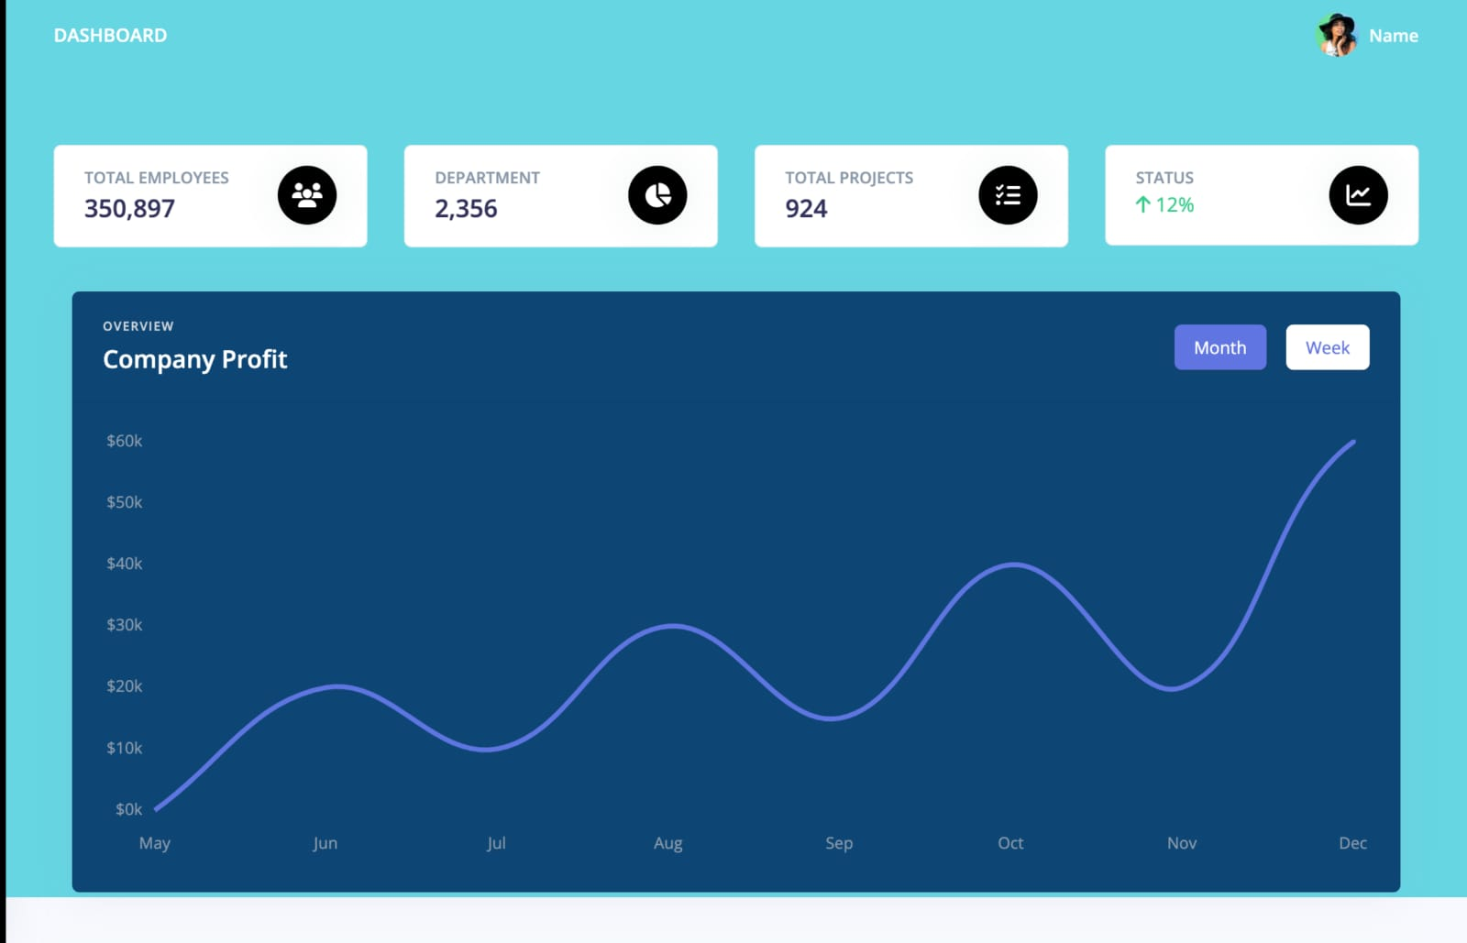

4.1 General Manager Dashboard

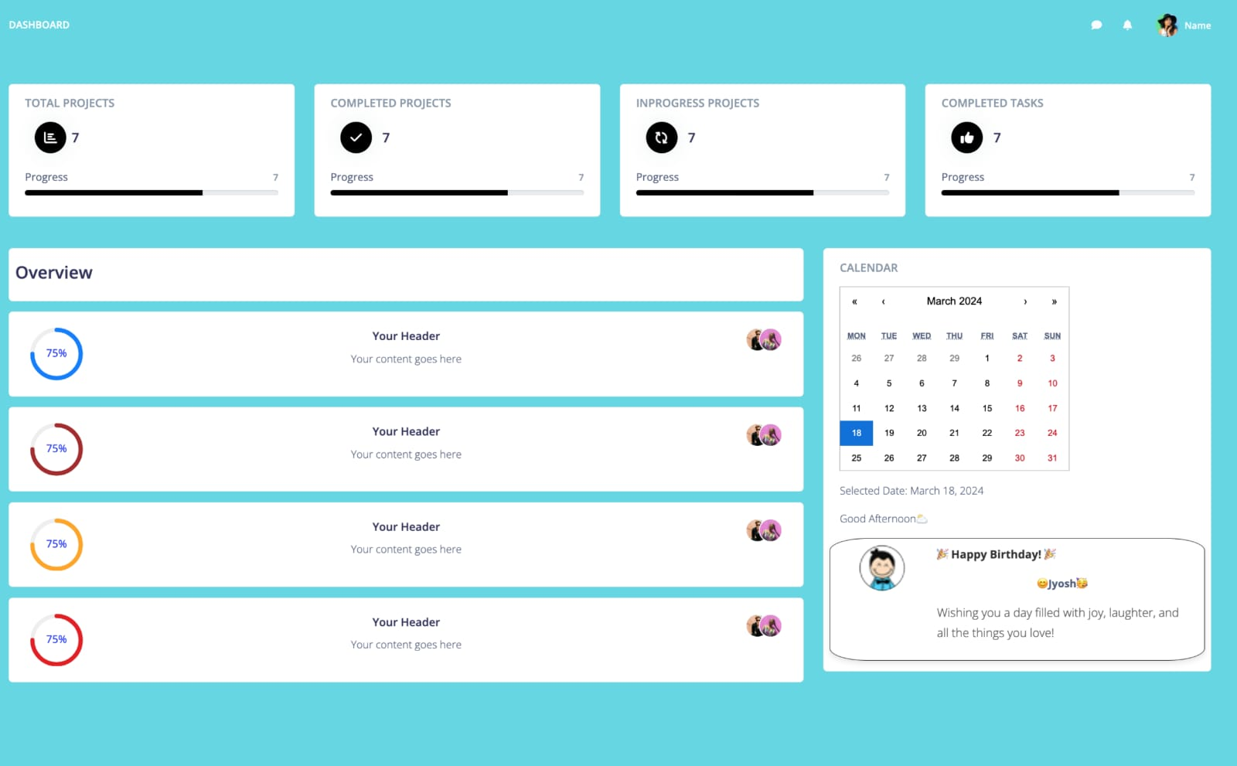

4.2 Project Manager Dashboard



4.3 Site Manager Dashboard

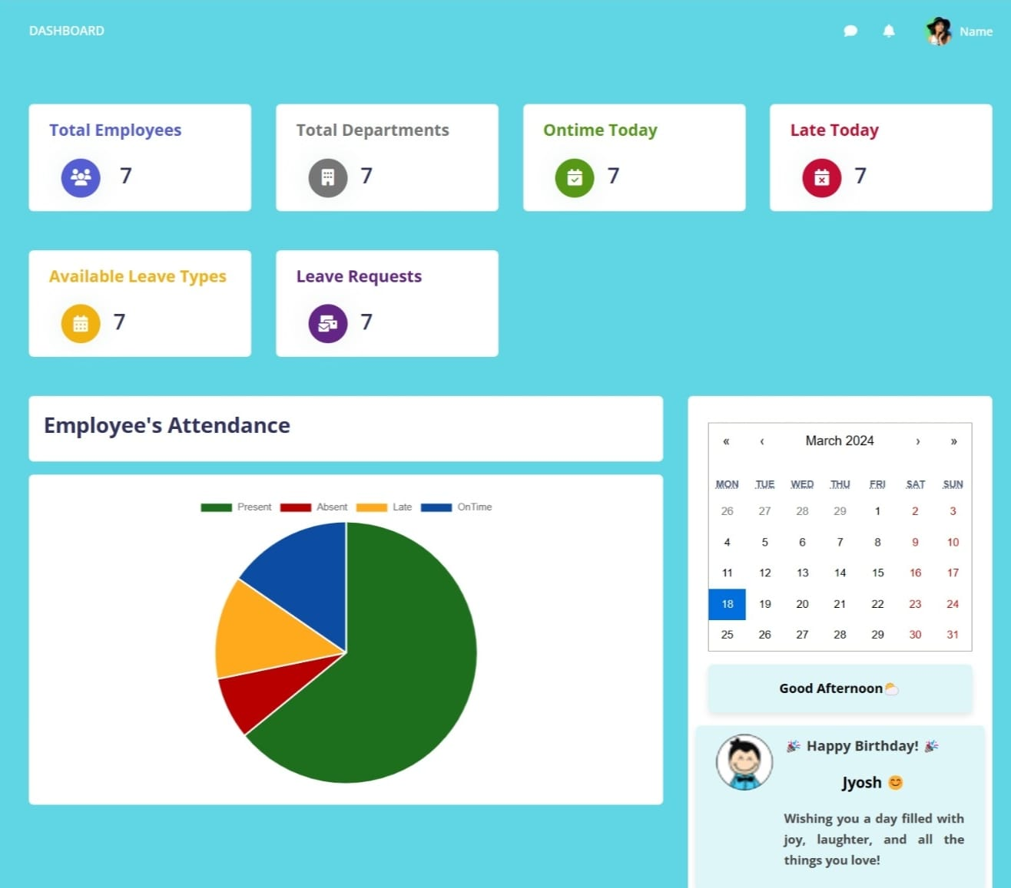

4.4HR dashboard

**Navigation**

AECP boasts a user-friendly navigation system, making it effortless to move between different modules, features, and functionalities. A clean and logical menu structure ensures that users can quickly find what they need. The three modules navigation bar is shown below:

 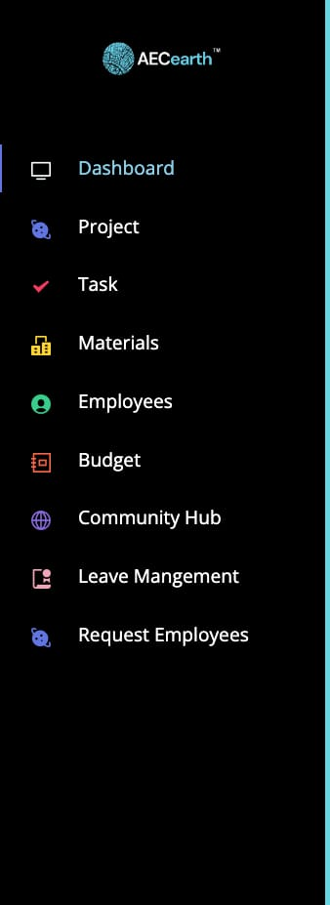 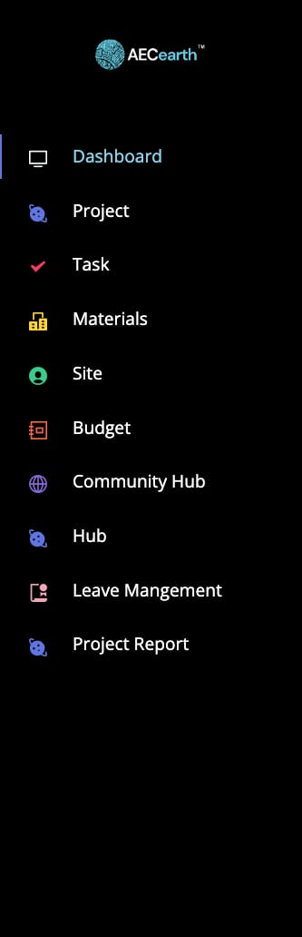 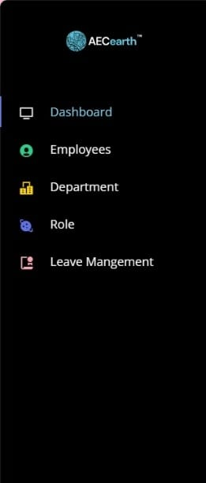

**4.5** general manager Navigation **4.6** Project Manager Navigation **4.7** Site Manager Navigation **4.8** HR Navigation

**Customization**

We understand that every Industry has unique needs, and AECP offers a range of customization options to cater to various requirements. Our customization features empower administrators to tailor the UI to align with the specific workflows and branding of your company, ensuring a personalized experience. Please note that the extent of customization may vary based on your chosen pricing tier or plan. Our flexible pricing structure allows you to select the level of customization that best suits your organization's needs and budget, providing a scalable solution for businesses of all sizes. Explore our pricing options to discover the level of customization that fits your requirements while staying within your budgetary constraints.

**Responsive Design**

AECP's UI is designed to be responsive, adapting seamlessly to various screen sizes and devices. Whether you're accessing AECP on a desktop or smartphone, the experience remains consistent and functional.

**User Profiles**

Each user, from employees to administrators, has their own profile page where they can manage personal information, preferences, and settings. This ensures a personalized experience tailored to individual needs. The user profile is shown below:

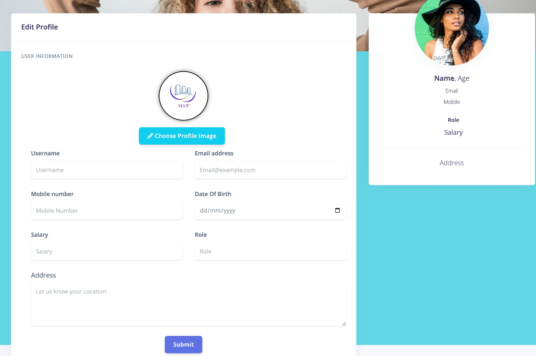

4.7 Profile Settings

**Real-Time Updates**

The UI is designed to provide real-time updates, and notifications, ensuring that users stay informed about critical events, project updates, task assignment and important communications.

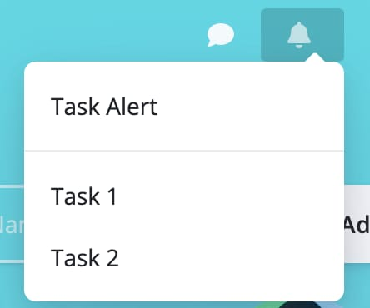

4.8 Notifications

**Accessibility**

AECP is committed to accessibility standards, making the platform usable by individuals with disabilities. We provide features and tools that support accessibility, ensuring inclusivity within your organization.

**5. System Architecture**

In this section, we delve into the underlying technology stack, databases, and integrations that power AECP's robust functionality.

**5.1. Technology Stack**

AECP is built on a modern and versatile technology stack that ensures scalability, security, and optimal performance. Our technology stack includes:

**Frontend**

AECP's user-friendly frontend is developed using industry-leading technologies such as React js and Material UI. This allows for a responsive and intuitive user interface.

**Backend**

AECP's backend is driven by a PHP, the robust technology known for their efficiency in building scalable network applications. We harness the power of PHP due to its remarkable speed and remarkable flexibility, especially when managing concurrent connections. This technology stack forms the backbone of AECP, ensuring smooth operations and rapid response times for users across the platform.

**Server Infrastructure**

AECP is hosted on cloud infrastructure, ensuring high availability, security, and scalability. We rely on Amazon Web Services (AWS) to deliver a reliable and performant service.

**Authentication and Security**

At AECP, we prioritize the security of user data. Our approach to user authentication involves the use of MD5 encryption, a widely recognized method for enhancing data security. In addition to MD5 encryption, we implement robust security measures to ensure the confidentiality and integrity of your data. Our system is designed to protect user information and maintain the utmost security throughout your interactions with AECP.

**5.2. Databases**

AECP's data management is primarily centred around SQL databases. Our SQL databases serve as the backbone of our data storage solution, efficiently handling both structured and relational data. This strategic choice ensures robust data organization, retrieval, and reporting capabilities, making AECP an ideal platform for meeting your specific data management needs.

**5.3. Integrations**

Seamless integrations enhance AECP's functionality and adaptability to your industry's needs. We offer integrations with a range of platforms and tools, including:

**Email Services**

AECP seamlessly integrates with popular email services, allowing for efficient communication and notifications through email.

**Calendar Services**

AECP seamlessly integrates with calendar services to enhance your scheduling experience. This integration ensures that your schedule is always up to date, displaying important events such as site managers and project managers birthdays and work anniversaries. Additionally, AECP leverages calendar services to prominently feature project due dates, providing valuable reminders as projects approach their end dates. This feature ensures that you and your team stay well-informed and organized, enhancing productivity and efficiency within your industry.

AECP's robust system architecture, technology stack, databases, and integrations are meticulously designed to provide a flexible, secure, and efficient platform for your organization's needs. Whether you need scalability, real-time communication, or custom integrations, AECP's architecture is built to adapt and perform.

**6. Security Measures**

Security is paramount in AECP, and we have implemented comprehensive measures to safeguard your data and ensure secure user access.

**6.1. Data Encryption**

Data within AECP is protected using state-of-the-art encryption techniques, including industry-standard protocols and algorithms. We employ robust encryption to secure data both in transit and at rest. This ensures that your sensitive information remains confidential and secure, mitigating the risk of unauthorized access or data breaches.

**6.2. Authentication**

AECP employs stringent authentication mechanisms to verify the identity of users. We implement strong password policies to ensure that only authorized individuals gain access to the platform. Our authentication methods, including MD5 encryption, provide an additional layer of security, further protecting user accounts.

**6.3. Authorization**

Authorization in AECP is carefully managed to grant appropriate access rights to users based on their roles and responsibilities. We implement role-based access control (RBAC) to ensure that users can only access the functionalities and data relevant to their roles within the organization. This fine-grained authorization approach enhances security and data privacy, reducing the risk of data exposure.

**7. Roadmap**

At AECP, we are dedicated to continuously improving our product to meet the evolving needs of our users. Our roadmap outlines our planned updates, enhancements, new features, and estimated release dates.

**7.1. Planned Updates**

Our commitment to excellence means we regularly release updates to enhance the functionality, security, and performance of AECP. These updates include bug fixes, optimizations, and other improvements. Our goal is to ensure that you always have the best experience when using our product.

**7.2. Enhancements**

In addition to routine updates, we are continuously working on enhancing existing features to make them even more powerful and user-friendly. These enhancements are driven by user feedback and our dedication to delivering top-notch performance.

**7.3. New Features**

We're excited to introduce the following upcoming features:

**1. Live Application Tracking**

Keep a real-time eye on your project's progress with live application tracking. Monitor each stage of your projects, identify bottlenecks, and optimize workflows for maximum efficiency.

**2. Auto-generate Payslip**

Simplify payroll processing with our auto-generated payslip feature. Effortlessly calculate and generate payslips for your employees, saving time and ensuring accuracy.

**3. Face Recognition**

Enhance security and access control with our face recognition technology. Implement advanced authentication methods to protect sensitive data.

**4. Auto-generate Project Roadmap**

Effortlessly create project roadmaps based on your project's milestones and objectives. Visualize your project's trajectory, making planning and execution more straightforward.

**7.4. Estimated Release Dates**

While we aim to release updates, enhancements, and new features as soon as they are ready, we understand the importance of transparency. Therefore, we provide estimated release dates for upcoming changes in our roadmap. Please note that these dates are subject to change based on development progress and testing.

Our roadmap is a testament to our commitment to delivering a product that grows alongside your Industry’s needs. We value your input and encourage you to share your suggestions and feedback to help shape the future of AECP. Together, we'll continue to make AECP an indispensable tool for your organization. Stay tuned for exciting updates ahead!

**8. Installation and Compatibility**

AECP is a web-based application, which means there's no need for installation on individual devices. Our platform is accessible directly from your web browser, making it easy for users to get started without any complex setup processes. Below, we outline the system requirements and platform compatibility to ensure you have a seamless experience with AECP.

**8.1. System Requirements**

Since AECP is web-based, it operates independently of your device's operating system. To access AECP, all you need is a device with the following:

**Web Browser**

AECP is compatible with modern web browsers such as Google Chrome, Microsoft Edge, Brave and more. Ensure you have the latest version of your preferred browser for the best experience.

**Internet Connection**

AECP requires an internet connection to access its features and data. A stable and reasonably fast internet connection is recommended for optimal performance.

**8.2. Platform Compatibility**

AECP is designed to be compatible with a wide range of platforms and devices. Whether you're using a Windows PC, Mac, Linux machine, or a mobile device, you can access AECP without any issues. Our responsive design ensures that the user interface adapts to various screen sizes, making it accessible on desktops, laptops, and smartphones.

**8.3. Installation Instructions**

To start using AECP, simply follow these straightforward steps:

**1. Open Your Web Browser**

Launch your preferred web browser.

**2. Visit AECP's Website**

Type in the URL for AECP’s web application. If you have a custom URL provided by your organization, use that.

**3. Log in or Sign Up**

If you're a registered user, log in with your credentials. New users can sign up for an account.

**4. Start Exploring**

Once logged in, you can start exploring AECP's features and functionalities.

Remember that AECP is accessible anytime, anywhere, as long as you have an internet connection and a compatible web browser. There's no need to worry about software installations or updates, as we handle all maintenance and upgrades on our servers.

With AECP's easy accessibility, you can efficiently manage your Industries tasks, projects, and communication without the hassle of traditional software installations.

**9. Getting Started**

Welcome to AECP! We're excited to help you streamline your organization's management and communication processes. This section provides step-by-step instructions to ensure a smooth onboarding experience.

**9.1. Step-by-Step Instructions**

To help you get started quickly, we've prepared a simple step-by-step guide that covers the essentials:

1. **Accessing AECP:** Open your preferred web browser and navigate to AECP's web application URL.
2. **Account Setup:** If you're a new user, sign up for an account by providing your details and organization information.
3. **Login:** For existing users, log in with your credentials.
4. **Dashboard Tour:** After logging in, we invite you to embark on a guided tour of our dashboard. As you hover over each option, informative tooltips will appear. This hands-on approach ensures that you'll quickly become comfortable navigating and utilizing all the available modules and features.
5. **Personalize Your Profile:** Click on your profile icon to access your settings. Here, you can update your profile information, and password.
6. **Creating Projects:** If you're a project manager, start by creating a project and assigning tasks to Site Managers. Use the project module to track progress.
7. **Task Assignment:** Assign tasks to Site Managers using the task management module. Set deadlines and priorities to keep everyone on track.
8. **Leave Management:** If you're an HR manager, use the leave management module to handle employee leave requests and maintain leave records.
9. **Timesheet:** For accurate time tracking, employees can use the timesheet module to record hours worked on tasks.
10. **Notifications:** Stay informed with real-time notifications like chat notifications and task notifications.
11. **Live Location Tracking:** Keep a watchful eye on your team's real-time geographical locations. This feature is invaluable for efficient resource allocation, ensuring employee safety, and making informed decisions.
12. **Calendar Management:** AECP's calendar tool goes beyond scheduling. It displays employee birthdays, work anniversaries, and project due dates, providing a holistic view of your organizational schedule.
13. **And More:** AECP continually evolves with user feedback and industry trends. Stay tuned for upcoming features, such as live application tracking, automated payslip generation, face recognition, and an auto-generated project roadmap. These enhancements will further empower your organization and simplify your daily operations.

**10. Contact Information**

For any inquiries, assistance, or feedback related to AECP, please feel free to contact us. We are here to provide you with the support and information you need to make the most of our platform.

**10.1. General Inquiries**

For general inquiries, partnerships, or any other non-technical matters, you can contact us via email at ‘mineittech@gmail.com’. We welcome your feedback, suggestions, and collaboration opportunities.

We value your input and look forward to assisting you with any inquiries or requests you may have. Your satisfaction is our priority.

**11. Legal Information**

We take legal matters seriously at AECP and aim to ensure transparency with all relevant regulations.

**11.1. Disclaimers**

While we strive to provide accurate and up-to-date information, AECP disclaims any warranties or representations, expressed or implied, regarding the accuracy, completeness, or suitability of the information on our platform. Users are responsible for verifying information and using AECP at their discretion.

**11.2. Terms of Service**

To understand the terms and conditions governing the use of AECP, please review our comprehensive Terms of Service. These terms outline user responsibilities, usage policies, and other important details regarding your interaction with our platform.

**11.3. Privacy Policy**

Protecting your privacy is a top priority for us. Our Privacy Policy explains how we collect, use, and protect your personal information when you use AECP. We encourage you to review this policy to understand how your data is handled.

**12. Version History**

**12.1. Version 1.0 (Release Date: [Date])**

**Initial Release**

The first version of our product, AECP, is now available! This marks the beginning of a powerful journey to streamline your organization's processes. In this initial release, you can expect:

1. Key features and functionalities available in this release.
2. Benefits in this version.

**1. Key features and functionalities available in this release**

* Site and Project manager Attendance System & Automatic Logout
* Project Management
* Task Management
* Site and Project manager Leave Management
* Timesheet
* Notification System & Email System
* Monthly Report Generator
* Profile Management
* Daily Calendar Management

**2. Benefits in this version**

* Streamlined Site and Project manager Management
* Efficient Project Coordination
* Enhanced Task Assignment
* Effective Leave Management
* Accurate Time Tracking
* Effective Communication
* Comprehensive Reporting
* User Profile Control
* Personalized Daily Calendar
  1. **. Key Changes**

**Initial Release**

AECP was introduced to the market, offering a comprehensive suite of features for efficient employee management, project coordination, communication, and productivity enhancement.

**User Authentication**

Robust user authentication mechanisms were implemented to ensure secure access to the platform, including the utilization of MD5 encryption for data security.

**Real-time Features**

AECP introduced real-time features within its platform, enabling instant messaging, notifications, and collaborative tools with minimal latency, all achieved without using external WebSockets.

**Database Integration**

The system seamlessly integrates SQL databases to efficiently handle structured data and relational data requirements

**Advanced Features**

The release included advanced features like calendar management, and an automatic logout feature for enhanced security.

**Enhanced Reporting**

AECP introduced a robust monthly report generator, providing comprehensive insights into employee performance, project progress, and productivity.

**Notification Centre**

A notification system and email integration were added to enhance communication and keep users informed about their tasks.

**13. Conclusion**

**13.1. Summary of Key Points**

In summary, AECP is a versatile web-based application designed to streamline various aspects of organizational management. With a wide range of features, including site managers attendance tracking, project management, task management, and more, it offers comprehensive solutions to enhance productivity and efficiency within your organization.

**13.2. Value and Benefits**

AECP brings significant value to your organization by providing a centralized platform for efficient HR management, project coordination, and communication. Its user-friendly interface, customization options, and real-time features empower your team to collaborate effectively, optimize resource allocation, and make data-driven decisions. By automating key processes, AECP enhances productivity, reduces administrative overhead, and fosters a more connected and informed workplace.

Discover how AECP can transform your organization's workforce management, communication, and productivity – start your journey today.